ATE/risk difference: $E(Y(1))-E(Y\left(0\right))$, risk ratio: $E\left(Y\left(1\right)\right)/E(Y(0))$, odds ratio: $\frac{E\left(Y\left(1\right)\right)}{1-E\left(Y\left(1\right)\right)}/\frac{E(Y(0))}{1-E\left(Y\left(0\right)\right)}$

Assumptions: Consistence: well defined exposure (no differ in exposure) and no interference (subjects’ outcomes are independent), Exchangeability: $X⊥Y$, $E(Y(x)|X=1)=E(Y(x)|X=0)=E(Y(x))$, Positivity: $P\left(X=x\right)>0$

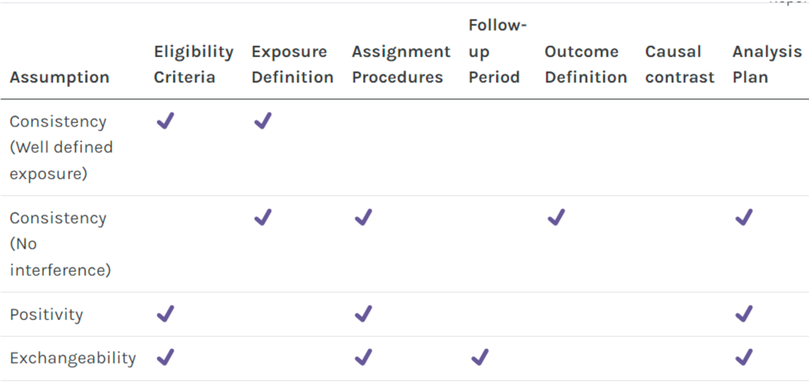Study design: randomized trials vs target trials (observational studies)

Observational studies: Cohort studies/Prospective/X→Y vs Outcome based sampling/ case-control studies/Retrospective/Y→X

Key elements in protocol: eligibility criteria, exposure definition (intervention&control), assignment procedures, follow-up period, outcome definition, contrast of interest, analysis plan

PS aims: overlap between exposure groups, balance the data

Propensity score: $P(X=1|C=c)$, package function: svydesign, svyglm

d-separation: path p is d-separated by {Z} ⇔ chain in {Z}/fork in {Z}/collider and descendants not in {Z}

Backdoor criterion: adjustment set {Z} to X on Y satisfies: descendants of X not in {Z}, {Z} d-separates (blocks) all paths between X and Y that contain an arrow into X (backdoor paths). Distribution of PS in groups should overlap, no PS values close to 1 or 0.

G-computation: Model $E(Y|C,X)$ Calculate for each individual: $\hat{E}(Y_{i}|C=c_{i},X=x)$ Estimate $E_{C}E(Y|C,X=x)$

$E\left(Y\left(1\right)\right)=E\left(Y | do\left(X=1\right)\right)=E\left(Y | C=0,X=1\right)P\left(C=0\right)+E\left(Y | C=1,X=1\right)P\left(C=1\right)$, $ATE=E\left(Y\left(1\right)\right)-E\left(Y\left(0\right)\right)$

$E\left(Y\left(0\right)\right)=E\left(Y | do\left(X=0\right)\right)=E\left(Y | C=0,X=0\right)P\left(C=0\right)+E\left(Y | C=1,X=0\right)P\left(C=1\right)$, $ATT=E\left(Y\left(1\right) | X=1\right)-E\left(Y\left(0\right) | X=1\right)$

$$E\left(Y\left(1\right) | X=1\right)=E\left(Y | X=1,do\left(X=1\right)\right)=E\left(Y | X=1,C=0\right)P\left(C=0 | X=1\right)+E\left(Y | X=1,C=1\right)P\left(C=1 | X=1\right)$$

$$E\left(Y\left(0\right) | X=1\right)=E\left(Y | X=1,do\left(X=0\right)\right)=E\left(Y | X=0,C=0\right)P\left(C=0 | X=1\right)+E\left(Y | X=0,C=1\right)P\left(C=1 | X=1\right)$$

Variables: outReg: confounders, var only ~ Y, no mediators, no var only ~ X, PSM: confounders, var only ~ Y, no var only ~ X

Weights: ATE: $1/P(X=1|C_{i})$ if exposed, $1/P(X=0|C_{i})$ if unexposed; ATT: 1 if exposed, $P\left(X=1 | C_{i}\right)/P\left(X=0 | C_{i}\right)$ if unexposed

MCAR: $P\left(M=1 | Y_{obs},Y_{mis}\right)=P(M=1)$, estimates consistent, se larger, imputation valid (consider only for efficiency gain)

MAR: $P\left(M=1 | Y_{obs},Y_{mis}\right)=P(M=1|Y_{obs})$, estimates consistent, se larger, imputation valid

MNAR: $P\left(M=1 | Y_{obs},Y_{mis}\right)$, $P\left(M=1 | Y_{mis}\right)$, estimates inconsist, se larger, imputation invalid

MAR/MNAR but not dependent on outcome: complete cases may still be unbiased for some analyses, consider multiple imputation for efficiency gain

MAR with dependency on outcome: multiple imputation; MNAR with dependency on outcome: sensitivity analysis